One Body, Different Languages
Bioenergetic Analysis and the Contemporary Understanding of Developmental Trauma
Restoring lineage • Creating translation • Inviting dialogue
Linda S. Hines, M.Ed., LPC, CBT
International Faculty for Bioenergetic Analysis

Abstract
The reason for writing this article is threefold: to restore lineage, create translation, and invite dialogue. Restoring lineage means bringing the early embodied and developmental contributions of Reich, Lowen, and Pierrakos back into the contemporary trauma conversation while also bringing the continuing evolution of contemporary Bioenergetic Analysis into greater conscious awareness within that conversation. This does not assume that later theories derived directly from their work. Creating translation means placing selected Bioenergetic and contemporary trauma terms beside one another—not as exact equivalents, but as different professional languages that may illuminate related dimensions of embodied human experience. Inviting dialogue means encouraging reciprocal understanding: Bioenergetic therapists can learn from contemporary attachment, neurological, and trauma research, while practitioners in those fields may come to understand Bioenergetic Analysis as a living psychotherapy that has continued to evolve while remaining grounded in its historical roots.
Introduction
Years ago, when I was a Licensed Professional Counselor and the supervisor of an adolescent residential chemical-dependency treatment center, I faced the challenge of helping mental health professionals and chemical dependency counselors communicate with one another. I intended to author a book called Speaking Two Languages because I could see that the two professions were often addressing remarkably similar clinical problems and using similar therapeutic processes, but they called them by different names. Because each profession had developed its own language, its practitioners did not always recognize how much they shared.
The problem was not merely academic. When chemical-dependency counselors described their work in everyday or self-help language, insurers could conclude that inpatient treatment was not medically necessary. Counselors had to learn to speak the language of mental health. Yet in learning the new language, the field risked losing sight of the practical wisdom already present in its own tradition.
I now recognize a similar problem in the treatment of trauma. Contemporary trauma approaches speak of autonomic dysregulation, implicit memory, incomplete defensive responses, attachment adaptations, and survival strategies. Bioenergetic Analysis describes grounding, muscular holding, restricted breathing, energetic charge, interrupted expression, and character adaptations formed within early relationships. These words are not identical, the methods are not necessarily interchangeable, and each model offers distinct contributions. Yet they may sometimes describe different dimensions of the same embodied human processes.
The problem may not be that contemporary trauma theory has ignored the body-oriented traditions that preceded it. The deeper problem may be that we have not learned to recognize one another across our separate professional languages. If so, an important task is not to determine which tradition owns the truth, but to translate between them—honoring their differences while identifying the clinical realities they share and recognizing a longer, richer history of embodied clinical knowledge.
I once heard someone say that every person wears the same invisible sign around the neck: ‘Make me important.’ I have never forgotten it. The statement applies not only to individuals but, in a quieter way, to professions and schools of thought. Each wants its language, history, and contribution to be recognized. When one professional vocabulary becomes dominant, other traditions may feel unseen—even when they have been observing and treating related human experiences for decades.
While rereading “Developmental Trauma: The Hidden Epidemic” in The Body Keeps the Score, I found myself wondering whether Dr. Bessel van der Kolk had studied the work of Wilhelm Reich, Alexander Lowen, and contemporary Bioenergetic Analysis. I wrote to ask whether he was familiar with this body of work and whether he had formed an opinion about its relevance to developmental trauma. I emphasized that these approaches are not identical, but that their areas of convergence and their different languages for describing embodied developmental adaptation seem worthy of dialogue.
As of the publication date of this article, I had not received a personal response from Dr. van der Kolk addressing these questions. Given his international prominence in the trauma field and the considerable demands on his time, this is entirely understandable. Nevertheless, the inquiry remains important—not only in relation to Dr. van der Kolk’s work, but also to the larger conversation between Bioenergetic Analysis and contemporary trauma theory.
The issue extends beyond whether one prominent trauma theorist is familiar with Bioenergetic Analysis. It points toward a broader historical and clinical question: the extent to which contemporary trauma theory has arrived at understandings that converge with—and sometimes appear to rediscover—principles articulated much earlier within body psychotherapy.
Although my letter named Reich and Lowen, the historical development of Bioenergetic Analysis also included the essential contributions of John C. Pierrakos, who collaborated with Lowen in developing the approach and co-founded the Institute for Bioenergetic Analysis. Pierrakos later established Core Energetics as a distinct body-oriented therapeutic model (Institute of Core Energetics, 2025; International Institute for Bioenergetic Analysis, 2026; Pierrakos, 1987).
Historical Lineages and Contemporary Convergence
Before comparing the clinical languages of Bioenergetic Analysis and contemporary trauma theory, it is helpful to place them within a broader historical context (Heller & LaPierre, 2012; Levine, 2010; Lowen, 1975; Ogden et al., 2006; Porges, 2011; van der Kolk, 2014). The following diagrams distinguish documented lines of development from later conceptual convergence. They are intentionally selective rather than exhaustive and are offered to orient the reader to the traditions and contributors most relevant to the present discussion.

Figure 1. Documented historical lineage.
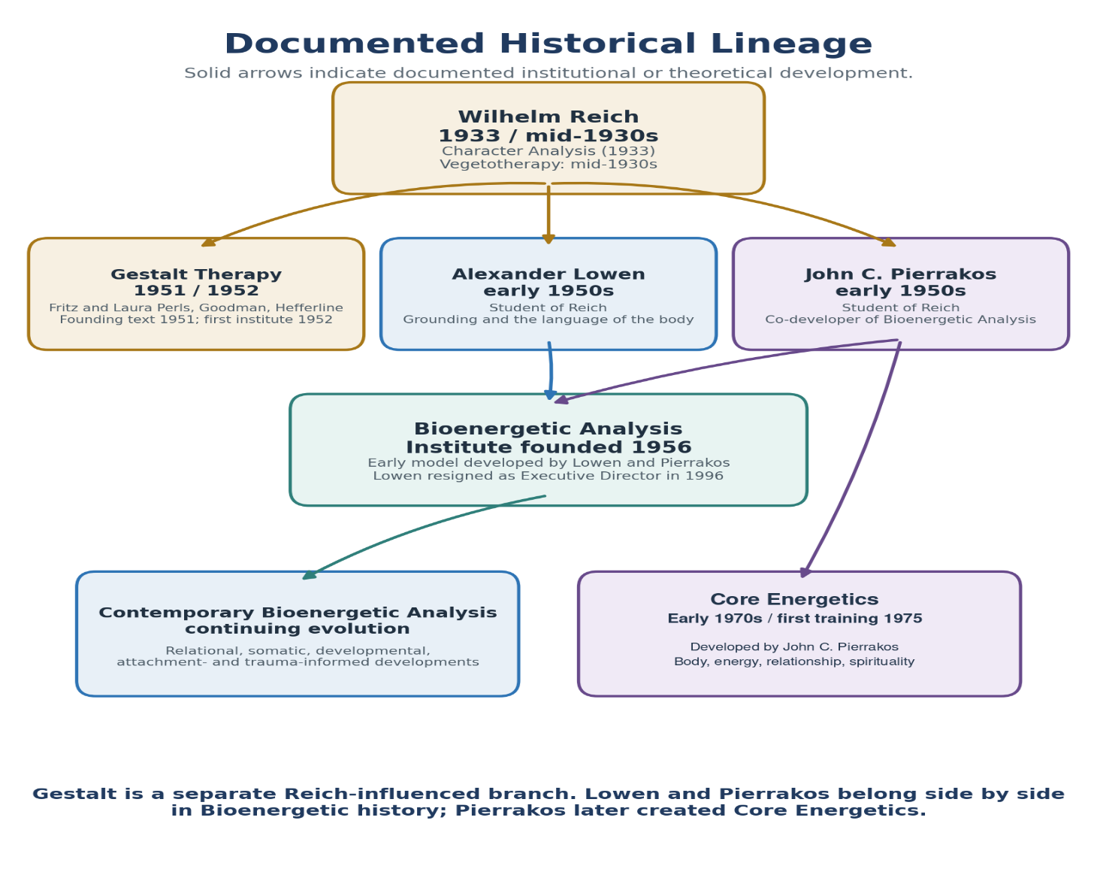 Figure 1. Reich's influence on Gestalt Therapy and on the Lowen-Pierrakos body-psychotherapy lineage.
Historical clarification: Gestalt Therapy is a separate Reich-influenced branch. Lowen and Pierrakos belong side by side in early Bioenergetic history; Pierrakos later developed Core Energetics. Contemporary Bioenergetic Analysis represents a continuing evolution rather than a therapy founded on the date of Lowen’s 1996 leadership transition.

Figure 1. Note. Historical dates and relationships are based on Reich (1933/1972), Perls, Hefferline, and Goodman (1951), Lowen (1958, 1975), Pierrakos (1987), and institutional histories of Bioenergetic Analysis and Core Energetics (Institute of Core Energetics, 2025; International Institute for Bioenergetic Analysis, 2026). Reich’s influence on Gestalt Therapy is represented principally through Fritz Perls. The Institute for Bioenergetic Analysis was founded in 1956; Lowen resigned as executive director in 1996. Core Energetics developed through Pierrakos’s work during the early 1970s, with its first separate training beginning in 1975.

Figure 2. Selected expressive and somatic lineages.
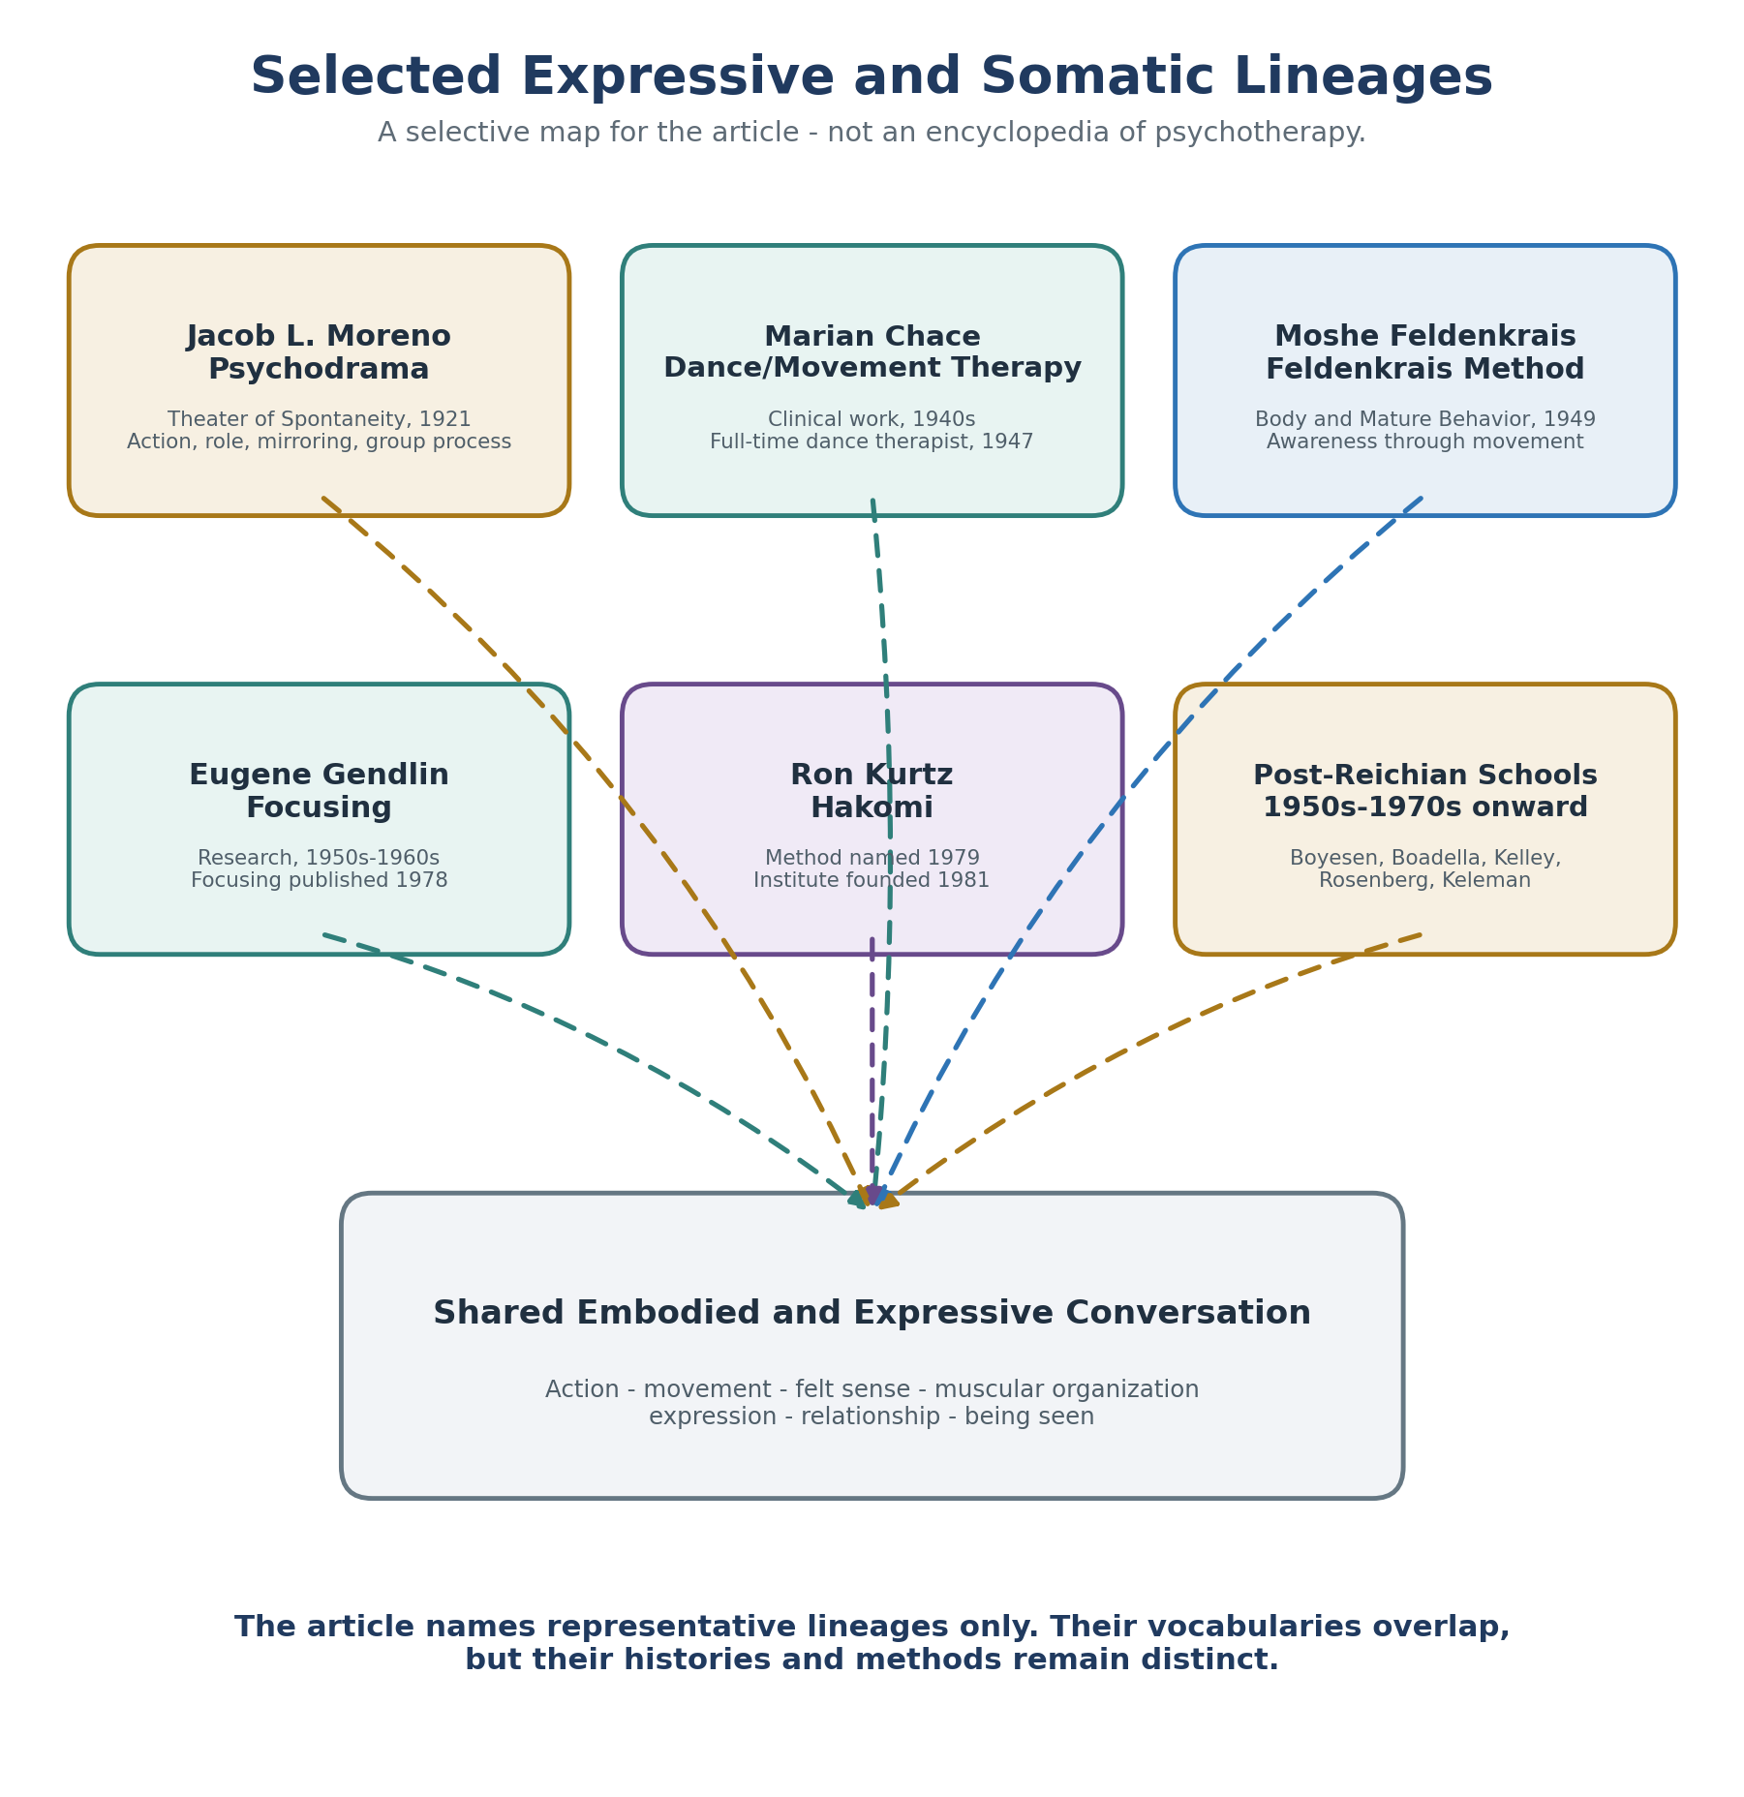
Figure 2. Representative expressive and somatic traditions that enlarge the conversation without turning the article into a survey textbook.
Editorial boundary: The traditions shown here clarify the article’s argument that several fields developed action-, movement-, body-, and relationship-based languages for overlapping human processes. The map is representative rather than exhaustive.

Figure 2. Source note. Historical dates and descriptions are based on Moreno (1924, 1947), the American Dance Therapy Association (n.d.), Chace (1993), Feldenkrais (1949), Gendlin (1978), the Hakomi Institute (n.d.-a, n.d.-b), Kurtz (1990), Geuter (2015), Keleman (1985), and Rosenberg et al. (1985). The identification of post-Reichian schools is also informed by the European Association for Body Psychotherapy (n.d.). The dashed lines indicate conceptual overlap, influence, or participation in a shared professional field; they do not establish direct training, derivation, or conscious reformulation.
Figure 3. Later trauma lineages and convergence
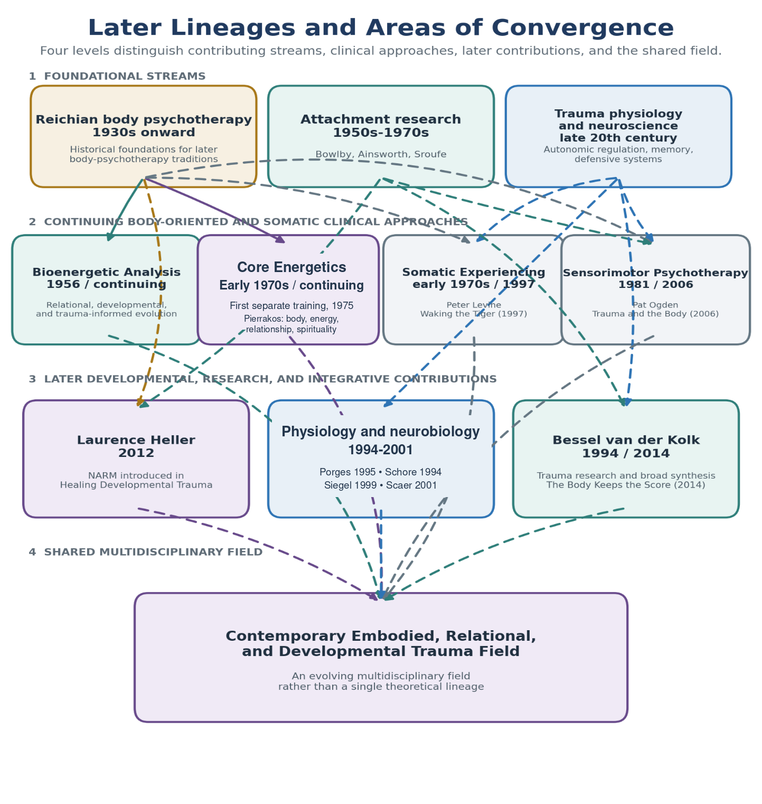Figure 3. Later somatic, developmental, relational, and neurological approaches.
How to read the dashed lines: Dashed lines indicate conceptual overlap, influence, dialogue, or participation in a shared professional field. They do not establish that a later theorist trained in, derived from, or consciously reformulated Bioenergetic Analysis.

Figure 3. Note. Dates and descriptions are based on foundational and representative works in attachment research, Bioenergetic Analysis, Core Energetics, Somatic Experiencing, Sensorimotor Psychotherapy, NARM, psychophysiology, interpersonal neurobiology, and trauma studies. Sources include Bowlby (1969), Ainsworth et al. (1978), Sroufe et al. (2005), Lowen (1958, 1975), Pierrakos (1987), Levine (1997, 2010), Ogden et al. (2006), Heller and LaPierre (2012), Porges (1995, 2011), Scaer (2001), Siegel (1999), and van der Kolk (2014). Solid lines represent documented historical development; dashed lines represent conceptual convergence, dialogue, or participation in a shared professional field.
Speaking Two Languages: A Comparative Translation
The following comparisons apply the Speaking Two Languages concept by placing selected terms from Bioenergetic Analysis alongside related terms from contemporary trauma theory. The purpose is not to suggest that the concepts are identical or that one can be substituted for another. Rather, the comparisons offer a form of clinical translation: they identify places where different theoretical traditions may be observing overlapping embodied processes while describing them through distinct professional vocabularies. The tables also preserve the important differences in each model’s history, assumptions, and therapeutic methods.
They follow a developmental and clinical sequence, beginning with adaptations formed in early relationships and moving through bodily memory, physiological regulation, grounding, defensive action, relational repair, and restored agency. The terms placed beside one another should not be understood as direct equivalents. Rather, each comparison asks whether different professional traditions may be observing related dimensions of an embodied human process while organizing those observations through different histories, assumptions, and therapeutic vocabularies (Heller & LaPierre, 2012; Levine, 2010; Lowen, 1975; Ogden et al., 2006; Porges, 2011; van der Kolk, 2014).
A Note on Interpretation and Scope
The comparisons that follow represent the author’s current interpretation and clinical analysis. They are offered as points of possible convergence rather than definitive equivalencies between theories. The fields of body psychotherapy and trauma treatment are extensive and continually developing; therefore, this selective comparison cannot include every relevant theorist, tradition, or clinical contribution. The omission of a particular theory or practitioner should not be interpreted as a judgment about its significance. The author welcomes corrections, additional perspectives, and continued dialogue that may deepen or refine this effort at translation.

Author’s Note
The interpretations and opinions expressed in this article are those of the author and do not necessarily represent the official positions of the International Institute for Bioenergetic Analysis or any of its affiliated societies or training institutes.

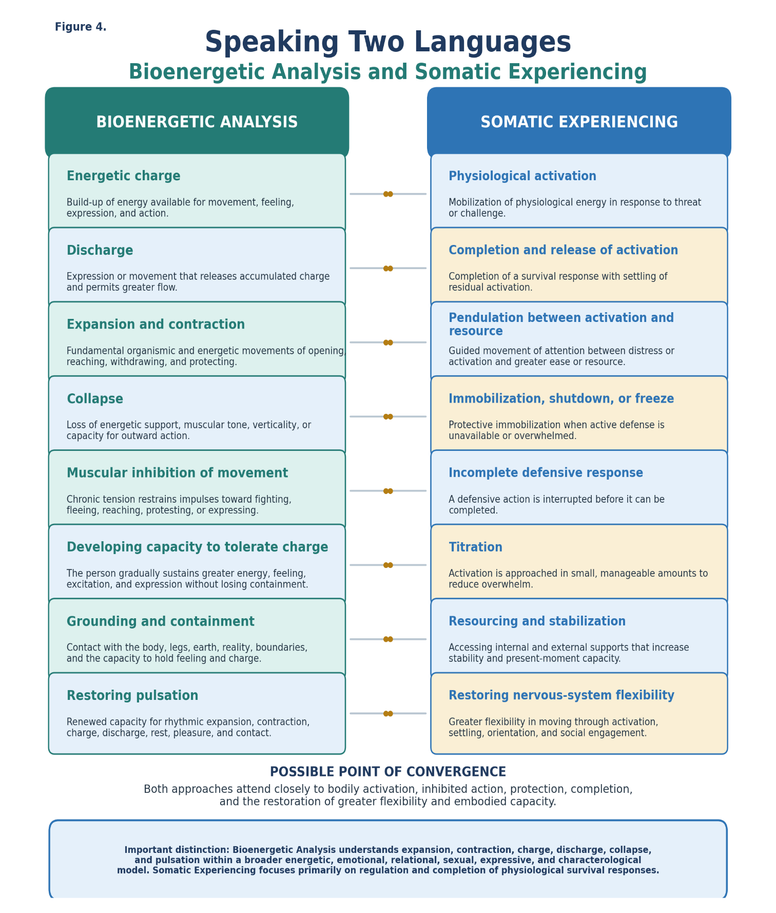
Note. Bioenergetic concepts are drawn primarily from Lowen (1958, 1975) and contemporary Bioenergetic literature. Somatic Experiencing concepts are drawn from Levine (1997, 2010). The pairings represent the author’s interpretive comparison.
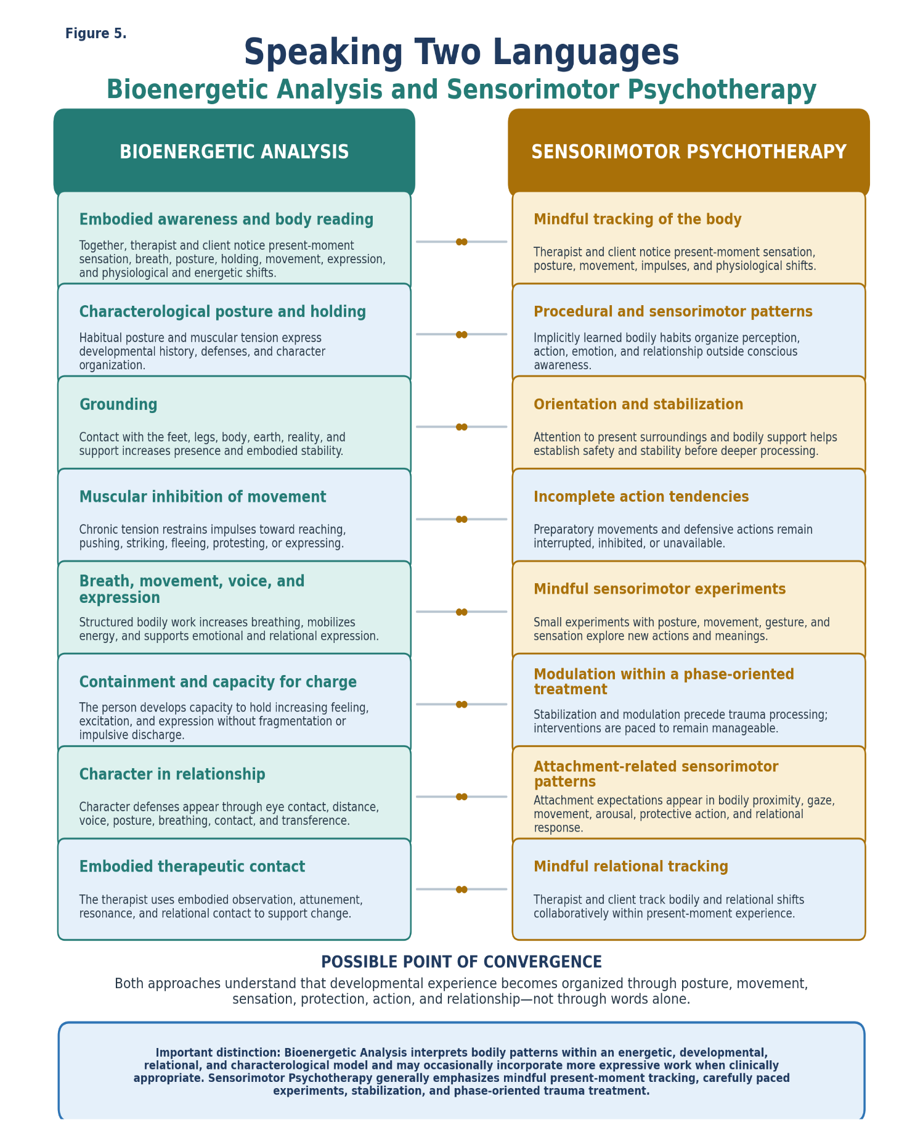 Note. Bioenergetic concepts are drawn primarily from Lowen (1958, 1975) and contemporary Bioenergetic literature. Sensorimotor Psychotherapy concepts are drawn from Ogden et al. (2006). The pairings represent the author’s interpretive comparison.
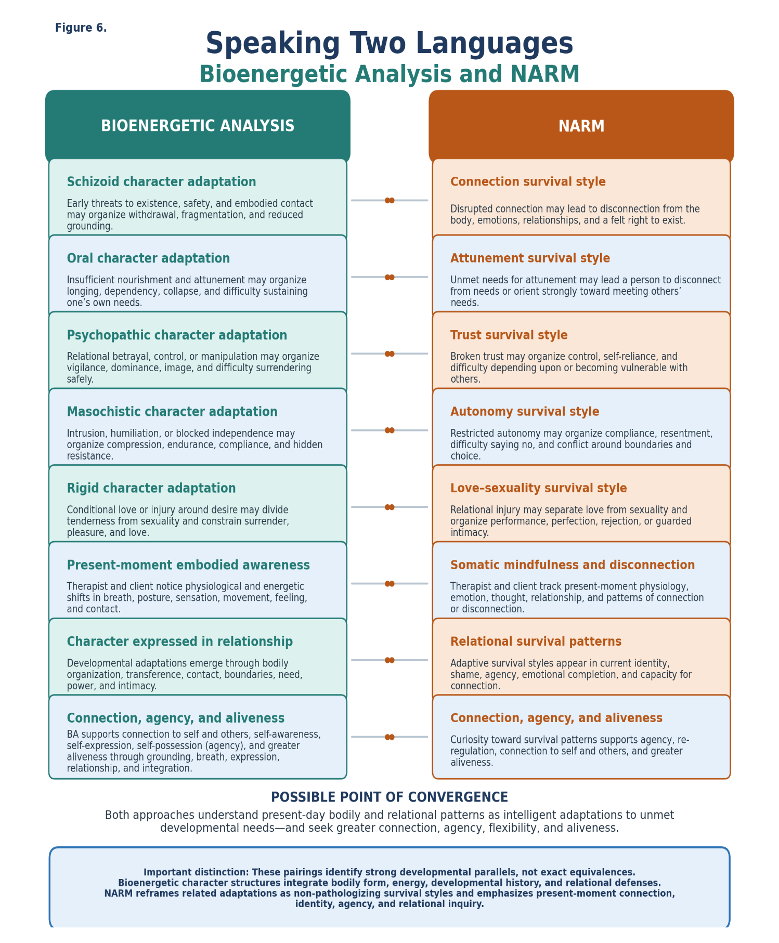
Note. Bioenergetic concepts are drawn primarily from Lowen (1958, 1975) and contemporary Bioenergetic literature. NARM concepts are drawn from Heller and LaPierre (2012). The pairings represent the author’s interpretive comparison.
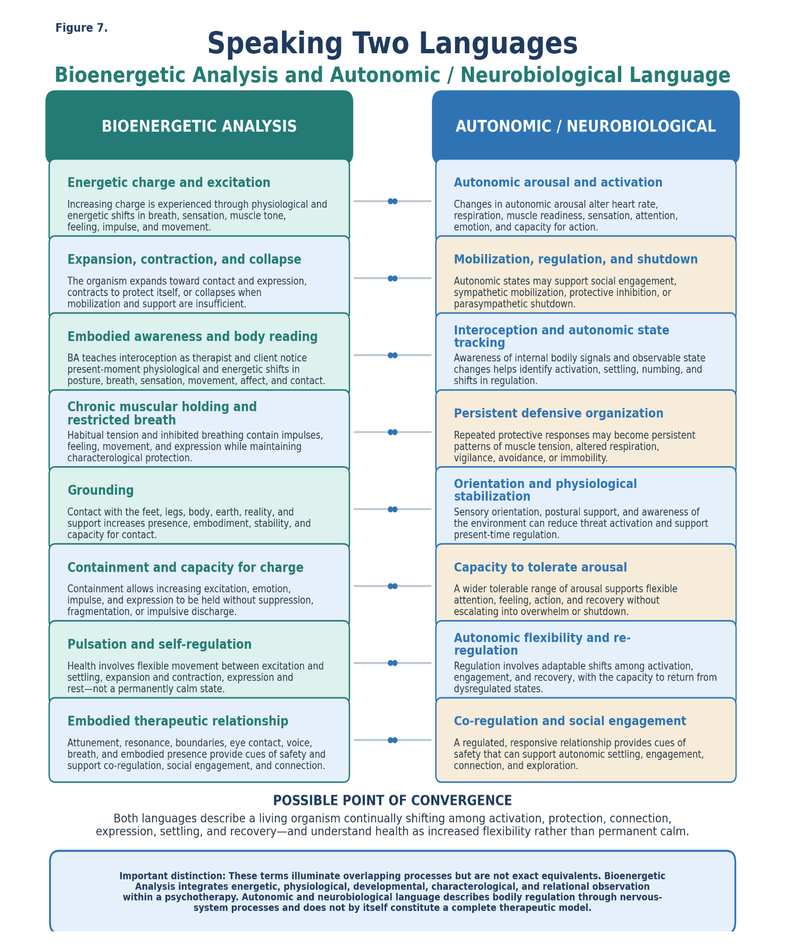
Note. Bioenergetic concepts are drawn from foundational and contemporary Bioenergetic literature. Autonomic and neurobiological concepts are drawn primarily from Porges (2011), with additional attention to contemporary trauma and interpersonal-neurobiology literature. The pairings represent the author’s interpretive comparison.
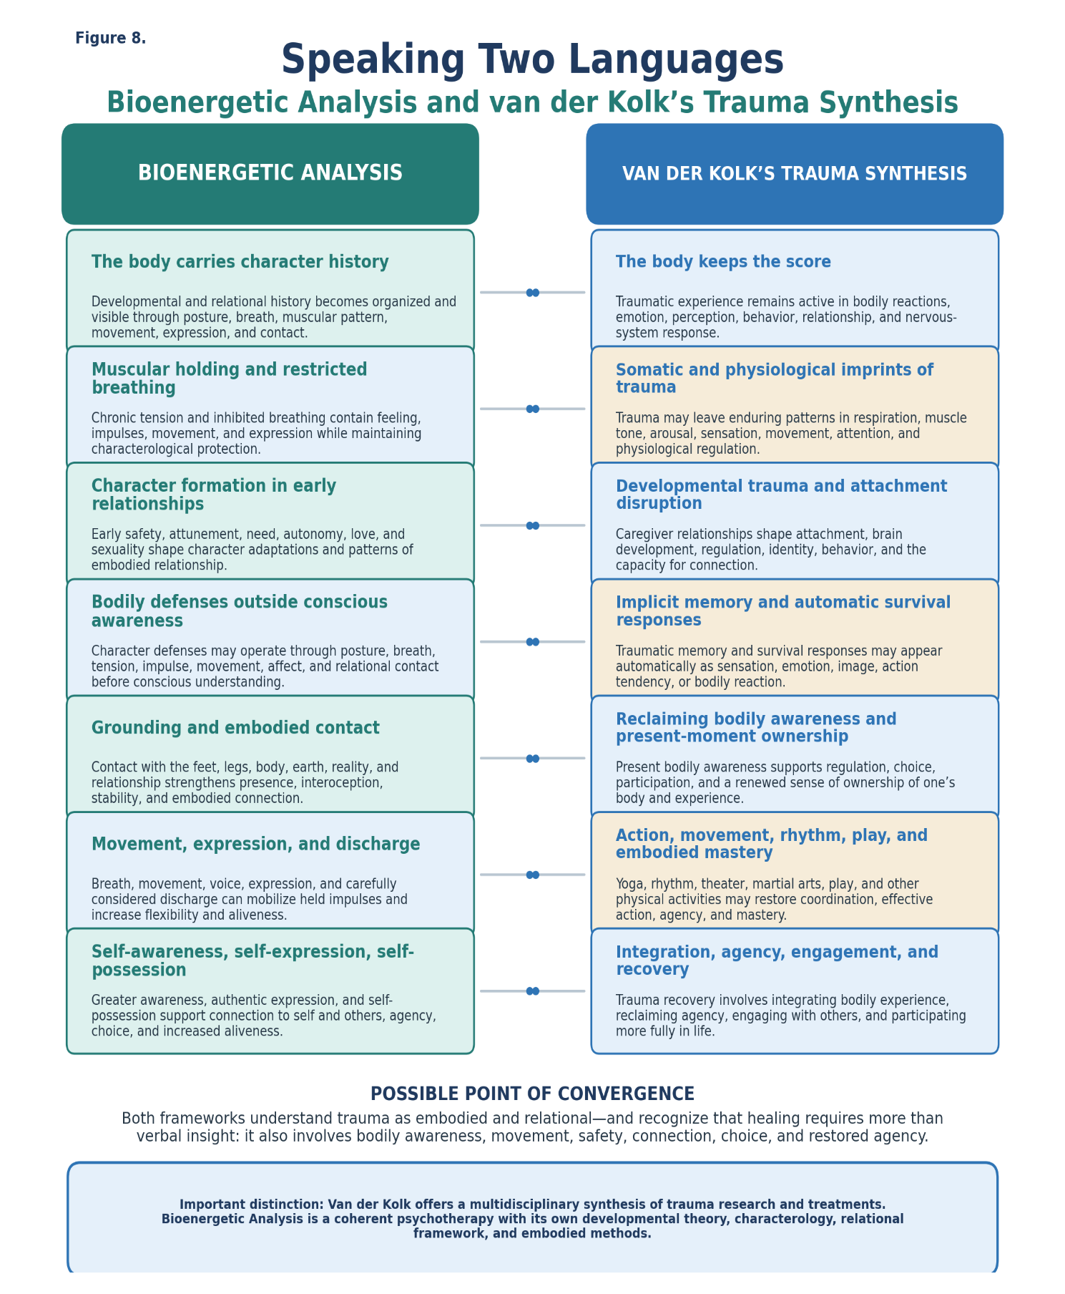
Note. Bioenergetic concepts are drawn primarily from Lowen (1958, 1975) and contemporary Bioenergetic literature. Van der Kolk’s multidisciplinary trauma synthesis is drawn from van der Kolk (2014). The pairings represent the author’s interpretive comparison.

What These Translations Reveal
Taken together, these comparisons reveal not a set of identical theories but a continuing conversation about how developmental experiences become organized in the body and how embodied healing may occur. Bioenergetic Analysis and contemporary trauma approaches frequently observe overlapping embodied processes while organizing and naming them through terminology shaped by their respective histories, assumptions, and clinical methods. Translation allows us to recognize shared clinical territory without erasing meaningful differences or asking any tradition to surrender the language that gives its work coherence. The terms are not always interchangeable, and the distinctions among the models remain clinically important. Nevertheless, several recurring areas of convergence become visible when their languages are placed side by side:
- Early relationships become organized in the body.
- Bodily adaptations often operate outside conscious awareness.
- Muscular holding, restricted breathing, autonomic activation, and survival responses offer different but overlapping descriptions of embodied protection.
- Healing involves regulation, movement, relationship, expression, agency, connection, and increased aliveness.
- Contemporary trauma approaches contribute increasingly precise neurological, attachment-based, and trauma-specific language.
- Bioenergetic Analysis contributes a coherent developmental theory, characterology, relational framework, and established embodied methods.
- Differences in terminology may conceal substantial areas of shared clinical understanding.
Bioenergetic Analysis Has Been Here All Along: Why Its Evolution Became Difficult to See
Several forces may have contributed to Bioenergetic Analysis becoming less visible within the contemporary trauma conversation:
- Reich became professionally marginalized. His later orgone theories and conflicts with the United States government overshadowed his earlier, clinically important work on character, breathing, muscular armor, and autonomic functioning (Sharaf, 1983).
- Bioenergetic Analysis developed largely outside academic psychiatry. Lowen’s work grew primarily through clinical practice and independent professional training institutes rather than through university psychiatry departments and major research centers (International Institute for Bioenergetic Analysis, 2026; Lowen, 2004).
- Language may have become a barrier. Terms such as energy, charge, pulsation, and character structure were clinically meaningful within Bioenergetic Analysis but could be difficult to operationalize through conventional research. Later terms such as arousal, autonomic regulation, procedural memory, and defensive response may have sounded more compatible with scientific and academic discourse (Geuter, 2015; Schroeter, 2022).
- Clinical knowledge and research knowledge followed different paths. Much of Lowen’s theory developed through sustained clinical observation of bodies and therapeutic processes. Contemporary trauma research increasingly developed through neurobiological, attachment-based, and longitudinal research, including Porges’s work on autonomic regulation and Sroufe’s attachment research (Lowen, 1958, 1975; Porges, 2011; Sroufe et al., 2005).
- Older Bioenergetic methods may have been misunderstood (Klopstech, 2005; Schroeter, 2022). Bioenergetic Analysis is sometimes reduced to hitting, kicking, screaming, or cathartic discharge. This caricature obscures grounding, containment, breathing, relational contact, self-awareness, interoception, co-regulation, and the careful reading of bodily defenses. Contemporary Bioenergetic Analysis has evolved beyond this limited perception.
- Contemporary Bioenergetic Analysis has evolved quietly. Contemporary Bioenergetic Analysis continues to evolve by increasingly integrating relational, attachment-based, neurological, and trauma-informed understandings while preserving its foundational attention to grounding, breathing, character, expression, and embodied relationship (Baum, 2017; Moselli, 2024; Schroeter, 2022; Shahri, 2023).
- New schools developed distinguishable identities. As emerging approaches became established, they developed their own names, concepts, methods, and training structures. These distinct identities helped practitioners teach and communicate each model clearly but may also have drawn attention away from areas of continuity with earlier body-psychotherapy traditions.
- Earlier knowledge may become more visible when its vocabulary changes. Once embodied experience could be described through neuroscience, attachment theory, implicit memory, and autonomic regulation, the larger professional culture may have become more receptive to hear ideas that had previously been expressed through the language of energy, character, muscular holding, and pulsation.

The Body as Living Developmental History
An important distinction can be made between trauma leaving its effects in the body and the developing self becoming organized through the body. Van der Kolk helped bring broad professional and public attention to the ways traumatic experience affects bodily sensation, physiology, movement, regulation, and the nervous system. Reich and Lowen emphasized a closely related and complementary dimension: the body is not simply a location where trauma leaves symptoms, but the living expression of a person’s developmental history (Lowen, 1958, 1975; Reich, 1972; van der Kolk, 2014).
This distinction is profound: The body does not merely keep a record of what happened. The developing body organizes itself in order to survive what happened.
From this perspective, muscular holding is not merely residual tension. It is an intelligent adaptation. A collapsed chest, immobilized pelvis, constricted throat, lifted shoulders, rigid spine, weak grounding, or interrupted breath may express how a child learned to preserve attachment, inhibit protest, contain terror, avoid punishment, or remain acceptable to a caregiver (Lowen, 1958, 1975; Reich, 1972).
This perspective brings three bodies of knowledge into conversation: the early embodied and developmental insights of Reich, Lowen, and Pierrakos; contemporary research on developmental trauma, attachment, implicit memory, and neurobiology; and the evolving relational, somatic, and trauma-informed practice of contemporary Bioenergetic Analysis. Together, they offer a fuller understanding of how the body carries history, organizes protection, seeks connection, and participates in healing and transformation.

Conclusion
The reason for writing this article has been threefold: to restore lineage, create translation, and invite dialogue. These purposes are interconnected. Restoring lineage makes translation possible, translation supports mutual understanding, and mutual understanding creates the conditions for respectful dialogue.
Restoring lineage means recognizing that Reich, Lowen, Pierrakos, and generations of Bioenergetic practitioners have long observed and worked with the ways developmental experience becomes organized through breathing, posture, muscular holding, movement, expression, relationship, and patterns of contact. Bioenergetic Analysis has been here all along, even when its contributions were not widely recognized within academic, neurological, or contemporary trauma discourse.
The comparisons in this article reveal substantial similarities in the embodied, developmental, and relational processes that these traditions observe and address. The theories are not identical, and their terms cannot simply be substituted for one another. Each theory names, organizes, and interprets experience through language shaped by its own history, assumptions, research, and clinical methods. Yet muscular holding and persistent defensive organization, energetic charge and autonomic arousal, grounding and physiological stabilization, or character adaptation and developmental survival strategy may illuminate related dimensions of embodied human experience. Translation allows us to recognize this shared clinical territory without erasing meaningful differences or asking any tradition to surrender the language that gives its work coherence.
Bioenergetic Analysis has also sometimes been misunderstood as a therapy centered primarily on hitting, kicking, screaming, or cathartic discharge (Klopstech, 2005; Schroeter, 2022). This limited perception obscures its grounding, containment, breathing, interoception, body reading, developmental characterology, relational contact, co-regulation, and embodied therapeutic relationship. It also fails to recognize the continuing evolution of the field. Contemporary Bioenergetic Analysis increasingly engages relational, attachment-based, neurological, and trauma-informed understandings while remaining grounded in its historical roots. This evolution does not diminish those roots. It keeps them alive by allowing the field to deepen its clinical understanding, refine its methods, and communicate more clearly with other professional communities.
Creating translation opens the possibility of reciprocal understanding. Bioenergetic therapists may benefit from learning the languages of attachment, implicit memory, autonomic regulation, neuroscience, and contemporary trauma treatment. At the same time, practitioners in those fields may become interested in what Bioenergetic Analysis has observed, preserved, and continued to develop. Through open exchange, each tradition may discover that it has knowledge to receive as well as knowledge to contribute.
Inviting dialogue asks something further of us. My hope—and one of the values guiding this article and this author—is that professionals across these fields can honor one another’s contributions and practice what we teach. We ask our clients to become grounded in themselves while remaining present and connected in relationship. Our professional communities can aspire to the same capacity. Good grounded connection does not require agreement, sameness, or the abandonment of our theoretical identities. It asks us to remain curious across differences, recognize one another’s contributions, repair misunderstandings, and stay in relationship.
The invisible sign that says “Make me important” reminds us of the deeply human wish to be seen, understood, and valued. Individuals carry that wish, and professional traditions may carry it as well. It need not lead to competition over who first discovered the body, trauma, regulation, or healing. One contribution does not become less important when another is acknowledged. We can make one another more visible without making anyone else invisible.
There is much to be enthusiastic about in this continuing evolution. Bioenergetic, somatic, relational, developmental, expressive, attachment-based, and neurobiological traditions each contribute valuable perspectives on healing and transformation. When these contributions are brought into open and respectful relationship, practitioners gain a fuller understanding of the people they serve and a wider range of ways to support regulation, expression, connection, agency, self-possession, and aliveness.
Restoring lineage, creating translation, and inviting dialogue are therefore more than scholarly purposes; they are relational practices. Together, they create an opportunity for Bioenergetic Analysis to be more accurately understood, for contemporary developments to be welcomed and integrated, and for all participating traditions to become more visible to one another. The body has always been speaking. Our continuing task is to learn its many languages, help others understand ours, and remain grounded, open, and connected as we discover what each tradition can contribute to healing and transformation.

AI assistance, accuracy, and scope statement
Artificial intelligence tools were used during the development of this article to assist with organizing material, comparing terminology, refining language, and creating charts. The author reviewed the resulting material and has made a good-faith effort to verify names, dates, historical relationships, theoretical descriptions, and source information. Responsibility for the interpretations, conclusions, and final text remains with the author.
This article is intentionally selective rather than encyclopedic. It highlights contributors and traditions most relevant to its central purpose: restoring an earlier body-psychotherapy lineage and creating translation with contemporary developmental-trauma language. No omission is intended to diminish the importance of an individual, discipline, or therapeutic tradition. Corrections and additional historical information are welcomed in the spirit of scholarly dialogue.
References
Ainsworth, M. D. S., Blehar, M. C., Waters, E., & Wall, S. (1978). Patterns of attachment: A psychological study of the strange situation. Lawrence Erlbaum Associates.
American Dance Therapy Association. (n.d.). Marian Chace biography. https://www.adta.org/marian-chace-biography
Baum, S. (2017). Containment, holding, and receptivity: Somatopsychic challenges. Bioenergetic Analysis, 27(1), 21–47. https://doi.org/10.30820/0743-4804-2017-27-21
Bowlby, J. (1969). Attachment and loss: Vol. 1. Attachment. Basic Books.
Chace, M. (1993). Foundations of dance/movement therapy: The life and work of Marian Chace (S. Sandel, S. Chaiklin, & A. Lohn, Eds.). Marian Chace Memorial Fund of the American Dance Therapy Association.
European Association for Body Psychotherapy. (n.d.). The evidence base for body psychotherapy. https://eabp.org/research/the-evidence-base-for-body-psychotherapy/
Feldenkrais, M. (1949). Body and mature behaviour: A study of anxiety, sex, gravitation, and learning. Routledge & Kegan Paul.
Gendlin, E. T. (1978). Focusing. Everest House.
Geuter, U. (2015). The history and scope of body psychotherapy. In G. Marlock, H. Weiss, C. Young, & M. Soth (Eds.), The handbook of body psychotherapy and somatic psychology (pp. 22–39). North Atlantic Books.
Hakomi Institute. (n.d.-a). About the Hakomi Institute. https://hakomiinstitute.com/about/about-the-hakomi-institute/
Hakomi Institute. (n.d.-b). Ron Kurtz. https://hakomiinstitute.com/about/ron-kurtz/
Heller, L., & LaPierre, A. (2012). Healing developmental trauma: How early trauma affects self-regulation, self-image, and the capacity for relationship. North Atlantic Books.
Institute of Core Energetics. (2025, March 11). Celebrating half a century of impact: An interview with Jac Conaway, graduate of the first class at the Institute of Core Energetics. https://www.coreenergetics.org/2025/03/11/celebrating-half-a-century-of-impact-an-interview-with-jac-conaway-graduate-of-the-first-class-at-the-institute-of-core-energetics/
International Institute for Bioenergetic Analysis. (2026). Faith in the body: Celebrating 70 years of Bioenergetic Analysis. https://bioenergetic-therapy.com/
Keleman, S. (1985). Emotional anatomy: The structure of experience. Center Press.
Klopstech, A. (2005). Catharsis and self-regulation revisited: Scientific and clinical considerations. Bioenergetic Analysis, 15, 101–132.
Kurtz, R. (1990). Body-centered psychotherapy: The Hakomi method: The integrated use of mindfulness, nonviolence, and the body. LifeRhythm.
Levine, P. A. (1997). Waking the tiger: Healing trauma. North Atlantic Books.
Levine, P. A. (2010). In an unspoken voice: How the body releases trauma and restores goodness. North Atlantic Books.
Lowen, A. (1958). The language of the body. Macmillan.
Lowen, A. (1975). Bioenergetics. Coward, McCann & Geoghegan.
Lowen, A. (2004). Honoring the body: The autobiography of Alexander Lowen, M.D. Bioenergetics Press.
Moreno, J. L. (1924). Das Stegreiftheater. Gustav Kiepenheuer Verlag.
Moreno, J. L. (1947). The theatre of spontaneity (2nd rev. ed.). Beacon House. (Original work published 1924)
Moselli, P. (2024). Insight on points of contact and differences between the polyvagal theory and Bioenergetic Analysis. Bioenergetic Analysis, 34(1), 13–15. https://doi.org/10.30820/0743-4804-2024-34-13
Ogden, P., Minton, K., & Pain, C. (2006). Trauma and the body: A sensorimotor approach to psychotherapy. W. W. Norton.
Perls, F., Hefferline, R. F., & Goodman, P. (1951). Gestalt therapy: Excitement and growth in the human personality. Julian Press.
Pierrakos, J. C. (1987). Core energetics: Developing the capacity to love and heal. LifeRhythm.
Porges, S. W. (1995). Orienting in a defensive world: Mammalian modifications of our evolutionary heritage—A polyvagal theory. Psychophysiology, 32(4), 301–318. https://doi.org/10.1111/j.1469-8986.1995.tb01213.x
Porges, S. W. (2011). The polyvagal theory: Neurophysiological foundations of emotions, attachment, communication, and self-regulation. W. W. Norton.
Reich, W. (1972). Character analysis (3rd enlarged ed.; V. R. Carfagno, Trans.). Farrar, Straus and Giroux. (Original work published 1933)
Rosenberg, J. L., Rand, M. L., & Asay, D. (1985). Body, self, and soul: Sustaining integration. Humanics.
Scaer, R. C. (2001). The body bears the burden: Trauma, dissociation, and disease. Haworth Medical Press.
Schroeter, V. (2022). Winds of change: The present state of Bioenergetic Analysis. Bioenergetic Analysis, 32(1), 51–56. https://doi.org/10.30820/0743-4804-2022-32-51
Shahri, H. (2023). What happens after detachment from relational trauma. Bioenergetic Analysis, 33(1), 41–54. https://doi.org/10.30820/0743-4804-2023-33-41
Sharaf, M. R. (1983). Fury on earth: A biography of Wilhelm Reich. St. Martin’s Press.
Siegel, D. J. (1999). The developing mind: Toward a neurobiology of interpersonal experience. Guilford Press.
Sroufe, L. A., Egeland, B., Carlson, E. A., & Collins, W. A. (2005). The development of the person: The Minnesota study of risk and adaptation from birth to adulthood. Guilford Press.
van der Kolk, B. A. (2014). The body keeps the score: Brain, mind, and body in the healing of trauma. Viking.
About the Author
Linda S. Hines, M.Ed., LPC, LADC, CBT, is an International Faculty member of the International Institute for Bioenergetic Analysis and President and Director of Training for the Dallas Society for Bioenergetic Analysis. She is a Licensed Professional Counselor and Licensed Alcohol and Drug Counselor in Oklahoma and a Licensed Marriage and Family Therapist in Texas. She has more than 40 years of experience in mental health, addiction treatment, and trauma care and maintains a private practice in Oklahoma City. Her integrative practice is informed by Advanced Heart-Centered Hypnotherapy, EMDR, Craniosacral Therapy, shamanic energy practice, and PsychoNeuroEnergetics, in which she is a practitioner and trainer. She is founder of SASE™—The Sacred Art of Somatic Embodiment. Linda may be contacted at lindahines@lindahines.com.

Publication Information
First published August 2026 at The Healing Journey (www.thehealingjourney.com). © 2026 Linda S. Hines. All rights reserved.
Recommended citation
Hines, L. S. (2026). One body, different languages: Bioenergetic Analysis and the contemporary understanding of developmental trauma. The Healing Journey. https://www.thehealingjourney.com/

